EVANDALE HISTORY SOCIETY INC
MINUTES - MONTHLY MEETING – 15 SEPTEMBER 2022

Attendees: Barry Lawson (President), Bob Strachan (Secretary), Laurie Wotherspoon (Treasurer), Stephanie Dean, Sally Wilkinson, John Lewis, Kim Polley, Charlie Watson, and Jan Foote.
Apologies: Neil and Lyn Louis, Jenny Carter, Judy Heazlewood, Tony McCormack, Maria Lawson, Lois Wotherspoon, Chris and Heather Leggett, Cameron Richards, Tennille Cox’ Williams, Stephanie Kensitt and Susan Hodson.
Minutes of previous meeting held 18 August 2022:
Bob proposed the minutes of the previous meeting be accepted. Seconded: Laurie Carried.
Business arising from the previous meeting:
Kennedy-Murray Vault. Laurie reported the bronze plaque and sandstone plinth are now in place in Pioneer Park. The NMC has agreed to remove the adjacent stump, level the surrounding area and seed with grass. Laurie said the cost came in around $2100 rather than $3000 as originally quoted as Dunn’s had a suitable plinth available from another order. Bob proposed a vote of thanks to Laurie for all his work on this project. Seconded: Jan . Carried. This item is now closed.
Murray Family information board – Pioneer Park. Jan has met with the school on this project and briefed the meeting on the proposal, as follows. Teacher Marcella Glachan (marcella.glachan@education.com.au) will lead the project from the School. It will involve a couple of small groups of Year 4 and 5 students in the extension program. They will first conduct a walk-around Evandale to identify suitable topics/sites for research. Students will then engage with the EHS for guidance, access to records etc. Hopefully one of the topics will be Kennedy Murray and the first school. The students will commence the project after 17 October and will work on the project between 1 and 3 pm on Mondays. Laurie and Jan to remain as the EHS contacts and provide oversight and guidance to the students as necessary. It was agreed that Laurie could spend up to $100 on the project without prior approval of the Society. Action Laurie and Jan provide periodic updates.
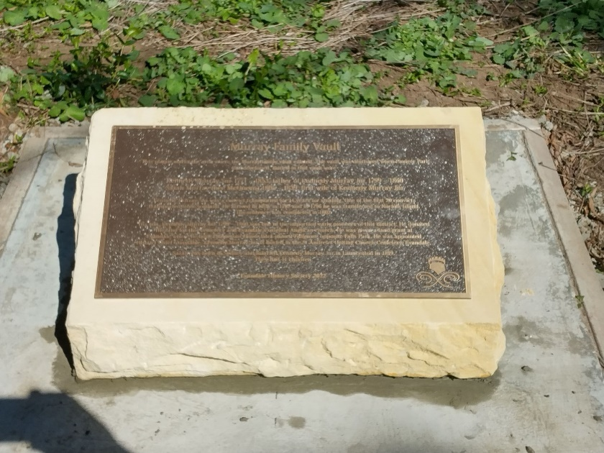
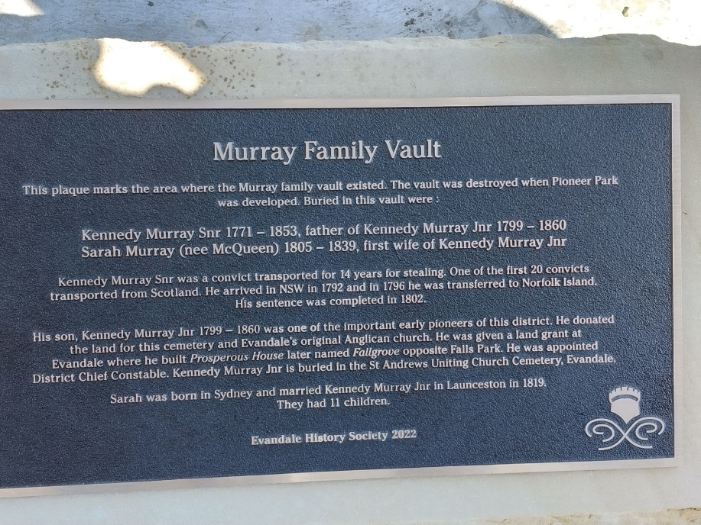
New IT Equipment. Barry is still waiting to engage with Harry Heathcote to configure the new equipment and transfer the data and programs from the old system Action: Barry to provide update as required.
Boer War data update. Kim stated she was happy for her research spreadsheet to be loaded to the web-site with an appropriate caveat – that the data should not be considered exhaustive or definitive. Also, that the sources quoted are suggested ones only and other more accurate/comprehensive sources might exist. Action: Bob to upload to the web-site with appropriate caveat.
Donation from Buffalo Lodge in memory of Peter Cruse. John said he had met with Leigh McCullough (NMC) and looked at the proposed site for the seat and benches in the small park in Russell Street adjacent the old butchers shop. Leigh told John, the existing cement bench could be relocated within the park and the new table be placed where the existing bench is. This will require a Development Application (DA) to be submitted. Barry volunteered to draft a DA. Action: Barry to draft a DA.
Converting non-digital video images to digital format. Barry has not been able to discuss with Harry Heathcote yet. Action: Barry to report.
Blessington New Hall and Ryan family. Tony has contacted Tim Cowley and provided him with information concerning New Hall Blessington. Tim is happy with the information. This matter will now be closed.
7EFTS unit crest. Barry has repaired the 7EFTS unit crest. This matter will now be closed.

Financial report: Presented by: Laurie. Moved: Laurie. Seconded: Charlie. Carried

Correspondence Inward:
14 August 2022 and 11 September 2022. Email from Sandra Graue re ancestors John Cross, George Cross and Mary-Anne Cross. (actioned by: Jenny)
17 August, 10 and 11 September 2022. Emails from Dorothy Evans re information on ancestors: Alfred Sutton (lived High Street c1910), David Murray (lived High Street c1910), Alphetta Sutton (died 1909 lived High Street), Harry Pogue (Evandale Station Master) also William Thomas (or Thomas William) Cox (not Clarendon Cox) licensee Jolly Farmer Inn at Perth. Dorothy is coming to Evandale on 10 October and would like to look at our records. Seeking photos/location of Station Masters House. (actioned by: Jenny) Note: Stephanie has quite a lot of research material on the Sutton/Murray family who lived in High Street – Jenny can you please liaise with Stephanie.
18 August 2022. Email from Julie Fitzpatrick to Jenny thanks for information on history of Nile and Lymington and ancestor James Pearce.
18 August 2022. Email from Peter and Pauline Shields East Brighton Victoria thanks to Jenny for information on Rev Robert Russell.
4 September 2022. Email from Sally Burgess re ancestor William Hartnoll. (actioned by: Lyn)
6 September 2022. Email from Don Garden RHSV advising of upcoming on-line workshop for Tasmanian History and Heritage Societies on writing local histories – It will be held on a Saturday – 6 hours and nominal fee. More details to be provided in next few days. Also copying some information on Tasmania History and Heritage grants. There was no interest from the members at the meeting attending. If any member not in attendance wants to ‘attend’ please let Bob know and he will forward details.
13 September 2022. Email Cameron Richards to Laurie re Murray family history.
Correspondence Outward:
10 September 2022. Email Jenny to Dorothy Evans concerning address of Jolly Farmer Inn Perth.
10 September 2022. Email Jenny to Jan and Gary Deering concerning Samuel Daymon (no information located).
September 2022. Email Lyn to Sally Burgess re William Hartnoll.

Bob proposed correspondence be noted. Seconded: Laurie. Carried
Research:
Lyn: Request from Sally Burgess for information on William Hartnoll. Sally will be visiting Tasmania from 19 September – 1 October and would like to visit Evandale and examine our records on William Hartnoll. Lyn has agreed to assist her.
Jenny:
Request from Jan and Gary Dearing concerning Daymon family - connection to Mrs Cox Clarendon’s family (no information located).
Request from Dorothy Evans re information of ancestors Alfred Sutton (lived High Street c1910), David Murray (lived High Street c1910), Alphetta Sutton (died 1909) Harry Pogue (Evandale Station Master) also William Thomas (or Thomas William) Cox (not Clarendon Cox) licensee Jolly Farmer Inn at Perth.
Request from Sandra Graue re ancestors John Cross, George Cross and Mary-Anne Cross.

New and General Business:
Old Printer. Lyn has advised her home printer is not functioning and was wondering what the plan was for the old printer in the EHS office. Lyn does a lot of printing at home on behalf of the Society. Bob proposed the old printer be donated to Lyn. Seconded: Kim. Carried. This matter will now be closed.
Heritage Grants from Arts Tasmania. Information on grants forwarded through RHSV. Grants may be made for research, exhibitions, displays, preservation of collections etc. Applications close 3 October 2022. Action Bob to send information to Laurie who will submit and application for funds for the Kennedy Murray metal information signage.
Celebration of Evandale’s bicentennial. Bob spoke about a number of Tasmanian towns that are planning to celebrate their bicentennials in the next year or two ie Bothwell. Kim spoke about some of the things Bothwell has planned for its bicentennial celebration in October 2022. Barry agreed to find an appropriate historical event in 1823 – 1824 which could be the focus of a possible celebration. All members are asked to think about whether we should have a bicentennial celebration, what date, what format and who/how it should be organised and be prepared to discuss at future meetings.
Photographs for Kim’s book. Kim reported she had obtained some suitable photos from the collection for her upcoming book. This matter will now be closed.
De-humidifier. Sally reported the de-humidifier is working well and the humidity has not only dropped in the museum room but also the display cabinets. This matter will now be closed.
Newspaper cuttings of local interest. Stephanie brought some newspaper cutting of local interest. This matter will now be closed.
New historical material. Bob said we had been given an old St Andrews Church Benevolent funds accounts for 1911-1917 in a small notebook and a letter from Mr Hawley circa 1950 re land boundary, also the book They Sowed we Reaped by Ivan Heazelwood and a facsimile of the Hobart Town Gazettes May 1816- December 1817. This prompted some general discussion about the state of the records and museum items. It was agreed this should be discussed in more detail at the next meeting.
Historic Trees. Barry said he was doing some work for the Launceston Horticultural Society on listing historic trees on public land in Evandale. He is listing the scientific name of each tree, common name, GPS co-ordinates, plain Englich location and historical relevance. Action: Barry to keep the Society updated on his research.

Next meeting: Thursday 20 October 2022 at 10:30.
Meeting closed at: 1215 am

